**Week 1 Introduction to the Future of Work: Industry 4.0 and 5.0**

**Activity 1: Research about yourself, Industry 4.0 and 5.0 (approx. 45 mins)**

**Activity 1.1 Let’s check your current skills profile and career aspirations…**

**Complete self-assessment skills profile via UEL Career Zone:**

1. Login into UEL Career Zone
2. Complete your profile if this is your first time in UEL Career Zone
3. Complete the Skills Assessment via <https://careerzone.uel.ac.uk/user/svc/skills.html> or select **skills** on the main navigation bar.

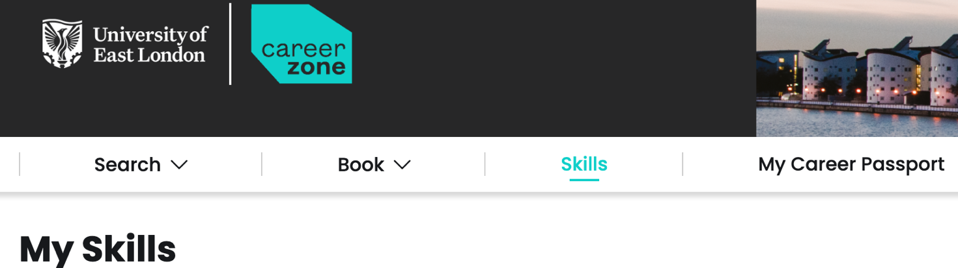

Please paste the results of the above results here:

**Complete this quiz to find out what tech career you would be ideal at:**

<https://www.bcs.org/it-careers/tech-career-quiz/>

Please paste the results of the above results here:

**Activity 1.2**

1. Activity 1.2: The writing should be no more than **100 words**
2. Please put in your own words what industry 4.0 and 5.0 means to you.
3. It must include specific skills you will need to have learned and how it will help you in the future

|  |
| --- |
| **Industry 4.0 and 5.0 means to me…**  Industry 4.0, to me, represents a shift where machines become powerful tools that assist humans in manufacturing and production. This involves automation, data exchange, and technologies like AI and IoT, leading to increased efficiency and productivity.  Industry 5.0 builds upon this by prioritizing human values. It focuses on using AI to complement human strengths, fostering collaboration between humans and machines, and ensuring sustainability and human well-being are central to the industrial process.  **The career you wish to do in this future…**  My BCS test shows I am suited to be Project Manager. I would then like to climb up the ranks and become a director sometime.   Ultimate goal is to set my own business. |

**Activity 2: Personal Development Plan (approx. 1hour) :**

1. Please complete the PDP and submit it on Moodle by the deadline provided in Moodle.

**Personal Development Plan**

|  |  |
| --- | --- |
| **Student Number** | 2611208 |
| **Student Name** | Shyam Vijay Jagani |
| The purpose of this form is to encourage you to think about and start planning your future career and to help you begin the process of looking for graduate-level employment opportunities.  Please complete the form as fully as you can. The more information you provide, the better staff can support you.  Please upload this completed form using the link in the Week 1 section of the CN5009/CN6007 Moodle site. Be sure to keep your own copy in your dedicated OneDrive folder for this module. | |
| **Section 1: What do you want to do when you graduate?** | |
| Which areas of Computing and IT interest you most? In which areas would you like to specialise? Have you started looking for graduate-level jobs? Have you considered further study e.g. an MSc or professional qualifications and certifications?  **Your thoughts:**  **I would like to work in the field for 2 years and then continue my higher education in a field that I will choose then.**  **Areas like, Data Analysis, Data Science, interest me the most. I have started researching about the current graduate jobs in my field. And also regarding potential Masters degree courses.** | |
| **Section 2: What do you need to do in order to get the job that you really want?** | |
| Do you know what skills and knowledge you will need to secure your ideal job? How will you develop those skills and knowledge? Do you know where to look for graduate level jobs? Do you have an up-to-date CV and a LinkedIn profile?  **Your thoughts and proposed actions: I have identified what skills and techniques I will ned and am working tirelessely to gain them. I will look into gaining mentoship, and help from other professional in the field as well as to increase my knowledge using other resources like books and online forums.**  **I have already sourced a lot of websites to look for graduate level jobs.**  **I have a LinkedIn profile and actively use and participate in it.** | |
| **Section 3: How can this module help you achieve your career goals and ambitions?** | |
| Are there any specific issues that you would like to cover in this module that are not part of the planned sessions? Are there aspects of the job searching and application process with which you would like additional support? Have you started looking at the work experience opportunities advertised on Moodle?  **Your thoughts:**  This module will help me use my knowledge and to gain experience in the industry with the placement. There aren’t any specific issues that I would like to cover in this module at the moment. I have not yet started lookin into the work experience opportunities advertised on moodle. | |

***Every week you will have a checklist to complete ensure you’re on the right track please ensure you complete this list.***

**Student Checklist for Week 1 Session**

✓ Complete tutorial one and two activities above.

✓ Uploaded this completed tutorial document in your dedicated module folder on OneDrive and Moodle link provided

Share your Reflective Logs if already on active Work Based Learning opportunity

Or

✓ Refer to Module Teams channel for Work Based Learning opportunities available

Apply for Work Based Learning Opportunity

Confirm with lecturer you have completed this activity.